DIS- Ceremonial axe or spud

SHAPE \\* MERGEFORMAT 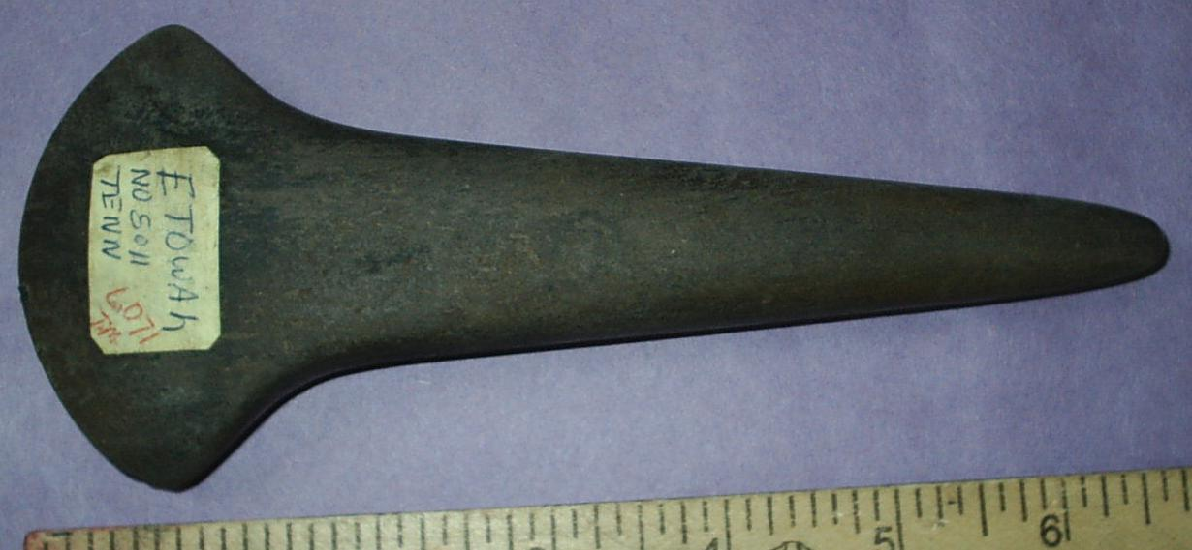 SHAPE \\* MERGEFORMAT 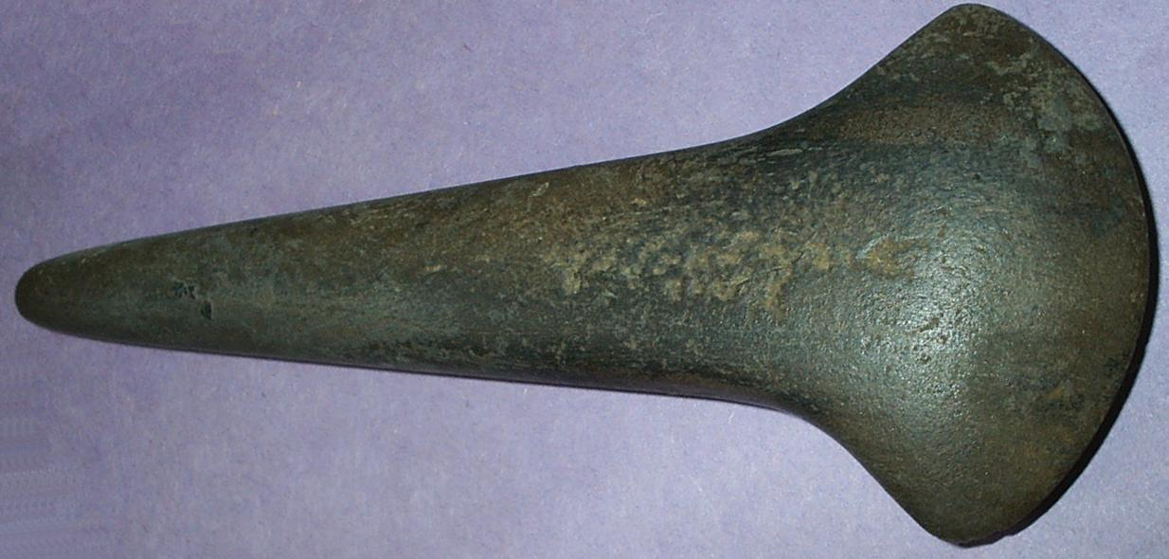

Ceremonial axe or spud from Etowah site, No 5011 (LO71) Georgia

INCLUDEPICTURE "../../Local%20Settings/Temp/scl12.jpg" \\* MERGEFORMATINET 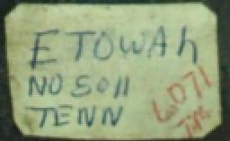

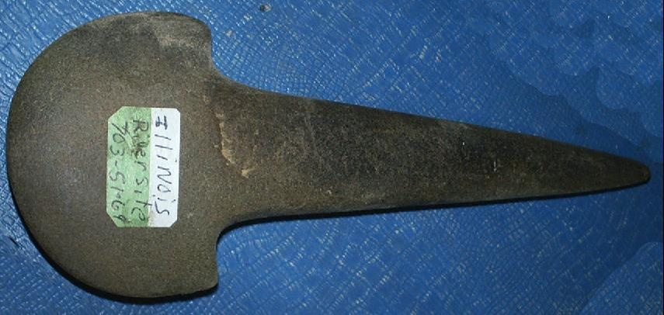 SHAPE \\* MERGEFORMAT 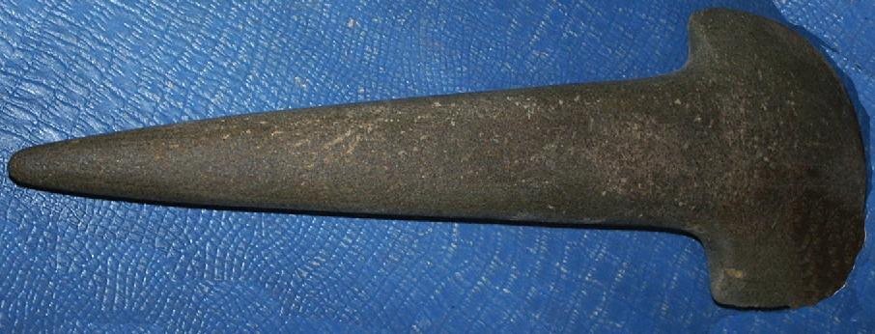

Ceremonial axe or spud from Illinois River Site, 701-S3-69

SHAPE \\* MERGEFORMAT 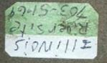

SHAPE \\* MERGEFORMAT 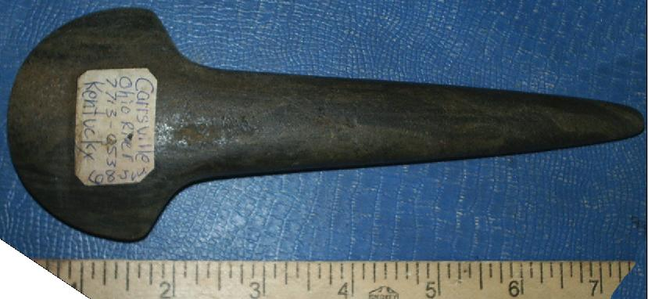 SHAPE \\* MERGEFORMAT 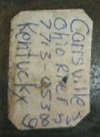

Carrsville, Kentucky, Ohio River 7713-053, C08 J-uu.

SHAPE \\* MERGEFORMAT 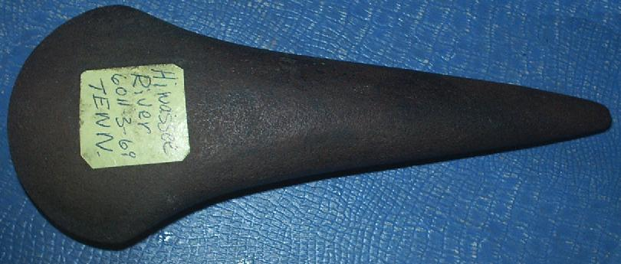 SHAPE \\* MERGEFORMAT 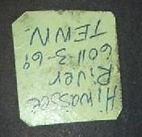

Hiwasee River, Tennessee, 6011-3-69